June 26, 2023

Forward-Looking Infrared (FLIR) Protocols for Buffalo Thermal Monitoring

Background

* Physiological changes due to infection, stress, and reproduction are often reflected in shifts in body temperature
* Monitoring animal body temperatures using thermal imaging remains an important goal, but faces difficulties in measuring accurate or repeatable measurements of individual temperatures.
* **A common factor of body temperature remote sensing is that thermal targets that best recapitulate core body temperature may not be large targets, and that proximity to animals will always be a complicating factor: Therefore, there is a likely tradeoff between the most accurate thermal targets and targets that can be sensed under non-invasive captive and field conditions.**
* We wanted to understand:
  + Pilot study - Correlation to Rectal Temperature [[Worm Experiment](https://drive.google.com/drive/folders/153FXxTkCU-YkAf37K_gsn0zP9Hls_FmZ?usp=share_link)]:
    - To understand where on the buffalo body can core body temperatures be measured most accurately, we compared rectal temperature (at capture) to thermal camera-based temperature for multiple body parts in Aug-Oct 2022. We found that an additive combination of left and right inner ear best predicted rectal temperature (n = 57, adj r2 = 0.66). This was closely followed by a combination of left and right outer ear base, a much more manageable target on a non-stationary bovid (n = 57, adj r2 = 0.5186).

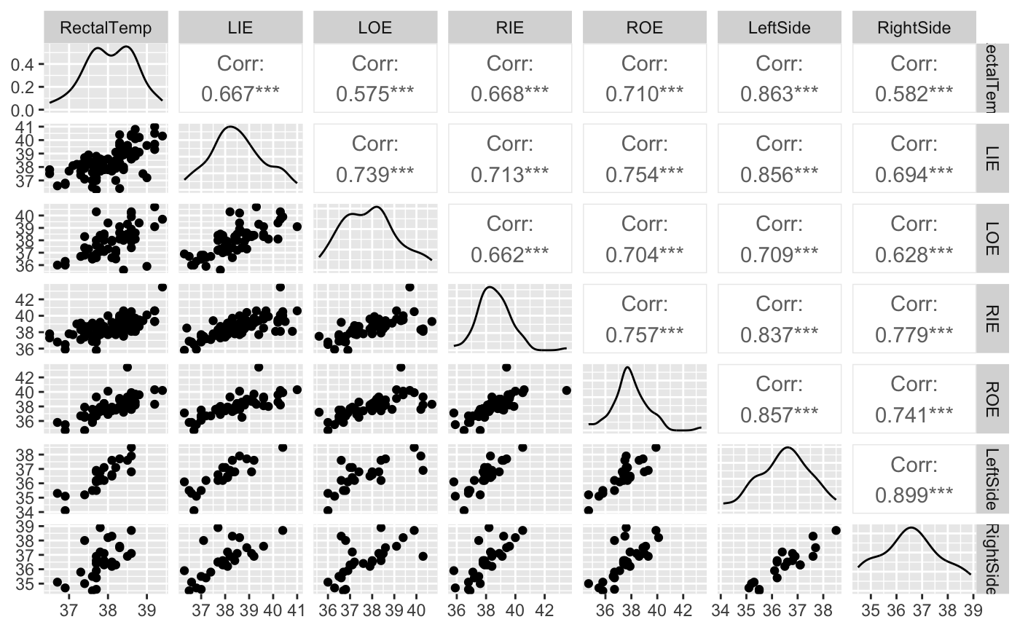

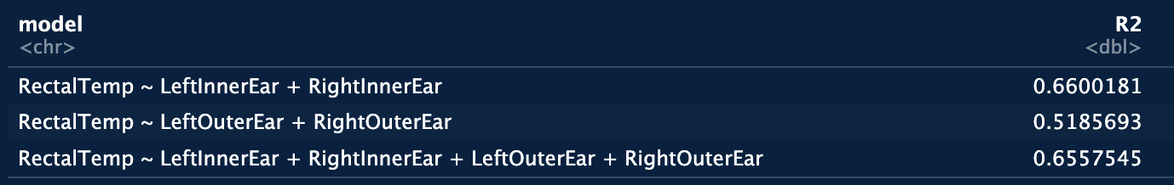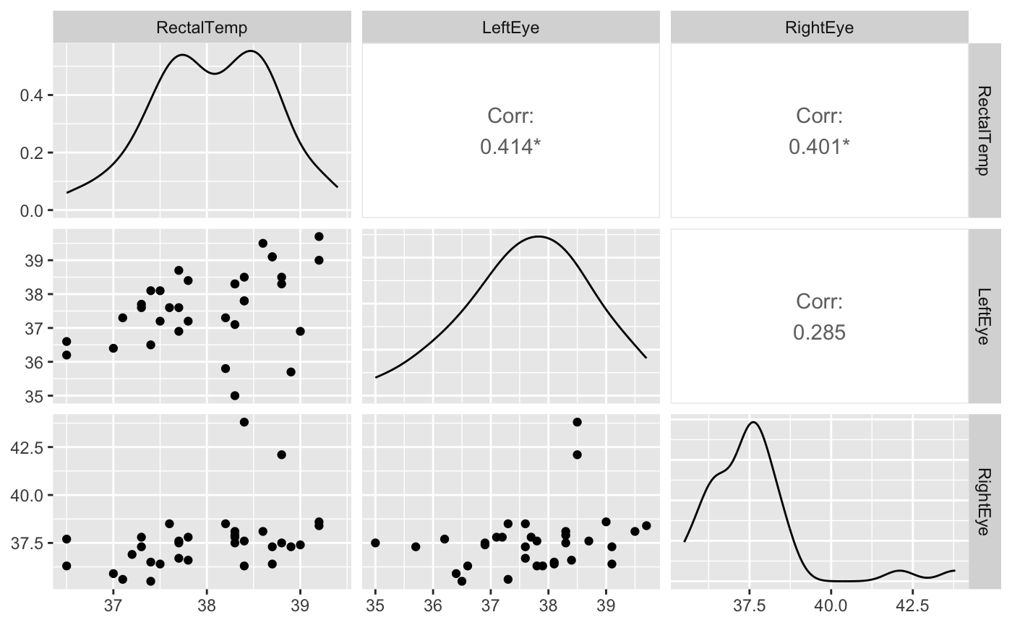

* + Pilot study - [Repeatability](https://drive.google.com/drive/folders/153FXxTkCU-YkAf37K_gsn0zP9Hls_FmZ?usp=share_link):
    - To understand how distance, time of day, and the body-target affects the ability to learn about animal body temperatures, we took photos of animals in early AM (6-9), late AM (9-12), early PM (12-3) and late PM (3-6) of various body parts at relatively random distances (though most less than 5m). This data has not been fully entered or analyzed.
  + [Capture timepoint sampling](https://drive.google.com/drive/folders/17fJ6Oz7T6wnqSnSIoS7XpAIGW4NMA03i?usp=share_link):
    - We will collect data on inner ear temperatures to test whether ‘remote’ body temperature data can be used to diagnose TB infection, and evaluate whether thermal cameras are sensitive enough to capture variation in responses to TB infection over time.
  + [Monthly Monitoring](https://drive.google.com/drive/folders/1LPur-R7SxpDEtedxTzDP_pgHYjumAoVx?usp=share_link):
    - We will take thermal images of each buffalo of the eyes, inner ears, outer ears, and flank to assess how these metrics from a distance align with temperatures at capture, and whether they can gather any information about disease progression from repeated measures.
  + [Distance Experiment](https://drive.google.com/drive/folders/1j_USE7bqlcMSIpD-qoG7H_1CAfbRIcIh?usp=share_link):
    - We will collect data on inner ear, outer ear, eye, and rectal temperatures, to test whether the predictive power of a given body target changes as a function of distance to that target and the heterogeneity of the target.
  + [Daily Eye Monitoring](https://drive.google.com/drive/folders/1eEB-Rscfm5B-aF_nAZY4Zhi_LJvq_tKE?usp=share_link):
    - We will take thermal images of the eyes (left and right) of buffalo as a daily thermal log of TB progression to measure pathological progression for use in ethical endpoint.
  + [Ex situ study](https://drive.google.com/drive/folders/1pdNRaIPREeIGkLZ_lYmeEVGdVlDWz3j8?usp=share_link):
    - We will test whether the size and the heterogeneity of a thermal target decays at different rates as a function of distance as an analog of the process occurring in the boma at a very controlled scale.

[**Capture timepoint sampling**](https://drive.google.com/drive/folders/17fJ6Oz7T6wnqSnSIoS7XpAIGW4NMA03i?usp=share_link)**:**

Materials:

* FLIR (charge before use, allow 5 mins for boot-up)
* Clip board
* Data Sheet
* Helper to position buffalo

Protocol:

1. During Captures, take photos of inner ears on the left and right side at <25 cm (the most accurate distance) – see the lower image: note the incredibly hot spot in the inner ear – the front of the ear can easily occlude this if not careful. Using a hand to stabilize the leading edge of the ear can greatly assist
2. It can help to take a photo of the ID tag then take the next two photos of the inner ear and progress to the next individual. After the capture, you can enter the data from the image numbers onto the capture datasheet as a backup in case there are any issues when taking pictures.
3. Photos need to be taken for all buffalo during a capture event (as possible – recognizing there are likely many other time constraints).

[***Capture Timepoint Sampling Datasheet***](https://docs.google.com/spreadsheets/d/1QRbBO9yxe-febiYPsVQtuXHwOSzpvglp/edit?usp=share_link&ouid=111948606230745482547&rtpof=true&sd=true)

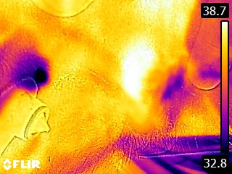

[**Monthly Monitoring**](https://drive.google.com/drive/folders/1LPur-R7SxpDEtedxTzDP_pgHYjumAoVx?usp=share_link)**:**

Materials:

* FLIR (charge before use, allow 5 mins for boot-up)
* Clip board
* Data Sheet

Protocol:

1. In 3-day bursts both before a capture and at monthly intervals take photos of both eyes, the back of the head on the left and right, the inner ear on left and right, and the flank of animal on left and right, as possible
2. Record each photo number the cell by the image type and animal ID (just the number – “FLIR” is not needed)
3. Record the estimated distance to the buffalo as a bin: 0-2.5m, 2.5-5m, 5-10m, 10+m
4. Photos need to be taken for all buffalo each day of sampling, as possible.

*Note the TB0 timepoint is an anomaly, where photos will be taken both before and after a capture.

***[Monthly Monitoring Datasheet](https://docs.google.com/spreadsheets/d/1M0jJ80Kw03KwYLavMf2GLzPNtBZu4dFu/edit?usp=share_link&ouid=111948606230745482547&rtpof=true&sd=true)***

[**Distance Experiment**](https://drive.google.com/drive/folders/1j_USE7bqlcMSIpD-qoG7H_1CAfbRIcIh?usp=share_link)**:**

Materials:

* FLIR (charge before use, allow 5 mins for boot-up)
* 8x8 grid with 2x2 cm hashing
* Tape measure
* Clip board
* Data Sheet
* Helper to position buffalo

Protocol:

1. Insert a rectal thermometer and allow the temperature to stabilize (30-60 seconds). In the meantime, proceed with the following steps. Return to record the final rectal temperature.
2. At the 30-day timepoint, get a game capture specialist or helper to hold the head of a sedated buffalo and blindfold in position for you.
3. On the surface of a focal sedated buffalo, have the helper hold an 8x8 grid (painted white and black in 2x2 cm squares) to estimate heterogeneity
4. Begin taking pictures of the:
   1. Eye (left, right)
   2. Inner ear (left, right)
   3. Ear base (left, right)
5. Repeat these measurements at:
   1. 25 cm (these can serve as the Capture Timepoint Sampling)
   2. 2.5 m
   3. 5 m
6. For each individual, this should result in 18 photos (each about 5 seconds) or <2 minute per buffalo in images
7. Based on time constraints, this should only be done for 2-3 buffalo per boma until we have data from ~5-6 animals.

[***Distance Experiment Datasheet***](https://docs.google.com/spreadsheets/d/1cMQ-hwU7AOq-Ibpx99TaiV6rEQnL-gy4/edit?usp=share_link&ouid=111948606230745482547&rtpof=true&sd=true)

[**Daily Eye Monitoring**](https://drive.google.com/drive/folders/1eEB-Rscfm5B-aF_nAZY4Zhi_LJvq_tKE?usp=share_link)**:**

Materials:

* FLIR (charge before use, allow 5 mins for boot-up)
* Google Data Sheet

Protocol:

1. On each buffalo in a boma, take thermal images of the left and right eye on each buffalo. It is best if the retina of the eye is perpendicular to the FLIR, or the buffalo is facing the camera.
2. Record the number of the image and the distance to the individual in a distance bin of 0-2.5m, 2.5-5m, 5-10m, 10+m
3. Repeat for each buffalo

*DATASHEET NEEDED*

[**Ex situ study**](https://drive.google.com/drive/folders/1pdNRaIPREeIGkLZ_lYmeEVGdVlDWz3j8?usp=share_link)**:**

Materials:

* Instant read thermometer (Buss/Netshitavhadulu)
* FLIR (charge before use, allow 5 mins for boot-up)
* Tape measure
* Clip board
* Large cardboard cutout with 2x2 5x5, 10x10 and 20x20 cut outs, tape, and paper
* Cut pieces of cardboard 2x2 (50), 5x5 (8), and 10x10 (2)
* Large matte water container

Protocols:

1. Fill a smooth-sided container (25 gallons) with warm water (38-45 C)
2. Record the temperature using the same rectal thermometer used *in situ*, and re-record between each trial – though the temperature should not change detectably.
3. Set up the filled contained on an array with the focal side not directly in sunlight
4. ***Distance:*** Mark distances from the container at .25, .5, 1, 2.5, 5, 10, 25, and 50 meters. Take one set of photos of the unobstructed target side at all distances close-far, then repeat for a total of three recordings per distance
5. ***Size:*** Using a cardboard box that is larger than the container with a cut-out with a 2.5x2.5cm, 5x5cm, 10x10cm, and 20x20cm squares, repeat the distance photos 3x (use paper and tape to cover the unused squares. Place the cardboard cutout so that there is a 2.5 cm gap between the container and the cutout
6. ***Heterogeneity:*** Tape cardboard cut-outs to the surface of the container that are 2cmx2cm (50x) , 5cmx5xm (8x) or 10cm (2x) within the 20cmx20cm cut out of the carboard box. Repeat the distance photos 3x with each of the square sizes. With each repeat, reshuffle the distribution of the cutouts.
7. With 8 distances in a control, 4 size experiments, and 3 heterogeneity experiments (8 experiments total) and three replicates, this should equal 192 photos. At approximately 5 seconds a photo and one minute for each setup, this should take about 30 minutes to complete.

[***Ex Situ Datasheet***](https://docs.google.com/spreadsheets/d/1M0jJ80Kw03KwYLavMf2GLzPNtBZu4dFu/edit?usp=share_link&ouid=111948606230745482547&rtpof=true&sd=true)